_____________________________________________________________________________________________

Begin Early: Getting in shape is essential for the different types of terrain you can find in Nevada. Break your gear in early!
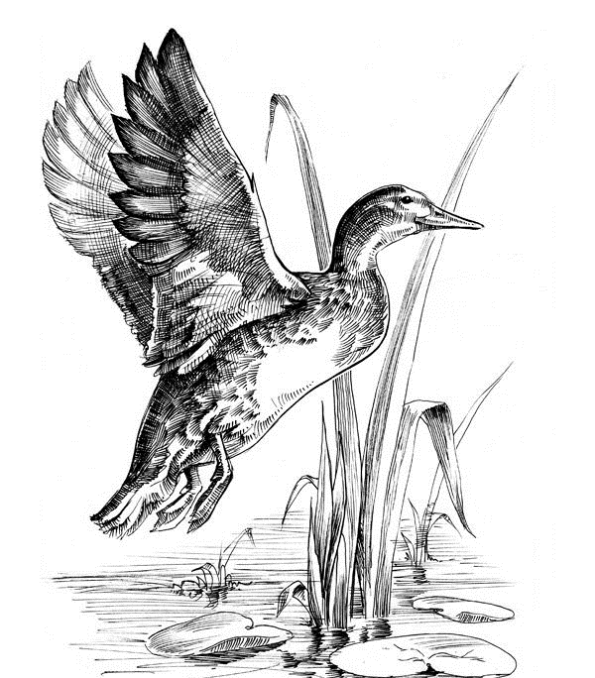
Get maps and start scouting: Maps and scouting gives you a head start for your hunt.
- Find areas to hunt and camp before the season opens.
- Know regulations, an attached wing of birds may be required.
- Know where private property is in your area.
- More than one location is beneficial in your area if your spot becomes occupied.
- Know if temporary blinds are allowed.
Know your Firearm/Practice shooting: Find a range and practice and be familiar with your firearm.
- Pattern your shotgun to know the effectiveness of your shot.
- Choose a choke to maximize the shots performance.
- Select the right type of shot for the species you are hunting.
- Try a sporting clays range to get familiar with all types of shooting situations. Once you get your game in sight you will be more confident of your shot.
Gear: Prepare your gear before you go.
- Rain Gear/warm gear/dog care
- Waders
- Decoys
- Lay down blinds (temporary)
- Set-up blinds (stand-up
- Shotgun with Plug to limit capacity to three shots.
- Non-toxic shot.
- Carrying device (wagon etc.)
- Game care: cooler or game bags to keep harvest clean cool and dry.
Know the game you are hunting: It sounds funny, but do some research on habits, food sources, and behavior of the species you are hunting, this will be beneficial in the field.
Prepare yourself and your vehicle for weather: Weather changes drastically in Nevada. Search historic weather in the area and prepare yourself and vehicle for anything.

